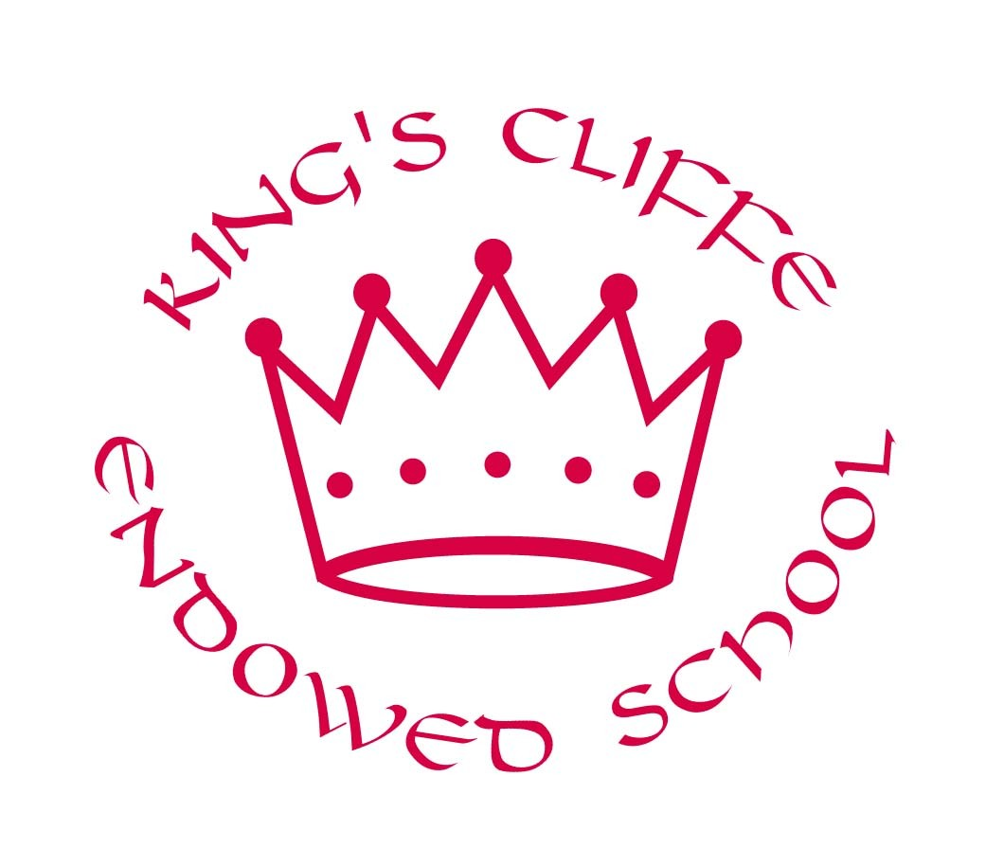
KINGS CLIFFE ENDOWED SCHOOL
SPECIAL EDUCATIONAL NEEDS & DISABILITIES (SEND) ANNUAL REPORT
JULY 2019

Kings Cliffe Endowed Primary School has a duty to report annually to all parents on the provision for children with Special Educational Needs or Disabilities (SEND) and implementation of our Equality Policy and Accessibility Plan.

Children with SEND have very specific needs with requires individual provision that is different from or additional to other children.

The Special Educational Needs Code of Practice lies at the heart of the school’s SEND Policy and sets out the processes and procedures that all organisations should follow to meet the needs of children. The Code describes a graduated approach that recognises that children learn in different ways and can have different kinds of SEND. If further support is required the child may be in possession of an Educational Health Care Plan or Statement.

Policies
The Special Educational Needs (SEND) Policy was reviewed and amended in April 2019 in line with the new SEND Code of Practice (2014). This is available to any parent on request and is published on the school website.

The Special Educational Needs Coordinator/ Inclusion Lead (SENDCo) is Barbara Yeo and the SEND Governor is Caroline Filby.

Number of pupils with SEND
We currently have 9 children this year that were identified as having special educational needs or disabilities:
5 children, who has specific learning needs dealt with in school with individual targets, modified resources and are working broadly in line with their key stage.
3 children, who have specialized individual educational targets which are highlighted by their Educational Health Care Plans.
1 child, who has continual support from specialised speech and language specialists and for whom the school is currently applying for an EHCP.
Parents, children and teachers are all involved in individual Education Plans (IEPs) which are developed for each of these children if it is felt necessary.

Progress of pupils with SEND
The steps progress of pupils with SEND is monitored every term to ensure progress is being made against individual targets. In reading, writing and mathematics 100% of children made progress against their individual targets. Where appropriate, some of the children are now being tracked through: Target Tracker, Pre- Key- stage standards as well as percentage of Target Tracker statements achieved. All progress is tracked termly with the class teacher, the assessment lead, the head teacher and the inclusion lead to ensure that the children are making progress; barriers are discussed and any interventions are reviewed for success. This review process is done throughout the year and helps ensure their individual and specific targets are reviewed accurately.
100% of SEND children have made progress. All SEND children have made progress in core subjects. 55% of SEND children have made 6+ steps progress in core subjects this year which is good progress.

Intervention programs for all these pupils have been implemented to ensure provision is in place for them to experience an inclusive education and to ensure that maximum progress is made.
Support is being given to parents and to staff to ensure that attendance of SEND children is as high as possible.

Budget allocation
The total income to the school’s budget allocated specifically to SEND for 2018-2019 was £60,015. This money is used for teaching assistant support both in the class and at non-teaching times, specialist educational advisors such as an educational psychologist, specialist dyslexia teacher, speech and language therapist, SEND ICT programs and apps as well as equipment such as specialist books, quiet space barriers and mental health support materials.

Deployment of staff and resources
Eight Support Assistants (LSAs) support alongside the class teachers by delivering specialized programs, general classroom support and 1:1 support for high needs children. This year support staff have been involved in a range of intervention programs, such as: Early Literacy Support, Early mathematics boosters, maths Rising Stars intervention, Phonics Booster, Speaking and Listening, Dyslexia programs, Occupational Therapy programs, mental health support, fine motor skills development and drawing and talking.

This year it has been a focus of the SENDCo to ensure that interventions are robust and that they are delivering impact for children and that teachers are held to account for the progress of SEND children. The SENDCo maps out this year’s school’s provision to support these children; supporting and meeting the needs of support staff in order for them to deliver individualised and small group teaching, tracking progress, assessing/observing individual children, and administrative work as well as liaising with parents, other agencies and specialists.

External agencies
This year the school has liaised with and had meetings with a number of external advisers including educational psychologists, speech and language consultants, physiotherapists, neurologists, IT consultants, occupational therapists, educational advisors and consultants.

Secondary school liaison
We continue to maintain links (meetings/visits/telephone calls) with our local primary and secondary schools and have undergone training with other special needs staff in our partnership to ensure information and skills are shared amongst schools. Special attention is also made for younger SEND children transferring to or from other schools. Transition to year 6 has also been a focus and information is gathered to ensure that all children are correctly catered for when they move on. If possible, stronger links between secondary schools are being requested to support parents with children with SEND.

Staff development
Staff have attended training for various programs. These include:

- Target Tracker implementation
- Supporting children’s behavior
- Happier Playtimes
- Assessment for learning
- Communication and Professional Relationships with Children, Young People and Adults-Teamwork
- Well being and mindfulness
- Physiotherapy, speech and language and occupational therapy - specific to the needs of individual children
- Social and emotional development and anger management
- Forrest school
- Pediatric first aid
- Clicker 7 training
- Epi-pen training.
- Drawing and Talking
- DSP updates

Equality Policy and Accessibility Plan
The Equality Policy was reviewed in March 2019 and the Accessibility Plan was reviewed in July 2019.

Under the Equality Act 2010 we are required to take proactive steps to ensure that disabled pupils, staff and governors, parents/carers and other people using the school are treated equally. We have incorporated our duties under the Equality Act 2010, and specifically on disability issues, into two main documents: our Equality Policy & Objectives, and our Accessibility Plan (our access to the physical environment, to learning, and to information for pupils and others in our school community with impairment or other needs that may put them at a disadvantage from others).

The School has identified a person responsible for Equality, Lynda Bowyer (Headteacher) and a school Equality Governor, Louise Bowen- West. The Equality Objectives for 2019 have been refreshed and added to and are available on the school’s website. In addition, an accessibility audit is conducted and includes the views and information sought or considered from staff and outside agency services that work with our children with protected characteristics and individual specific needs.

The school has very small numbers of children of other cultural or racial backgrounds than White British or that are described by their parents/carers as having a disability.
Due to the small numbers involved trends are difficult to establish, children with specific needs (due to diversity, medical or learning needs) are provided with interventions on a needs basis to ensure maximum support to close any gaps.

The school have a number of children with specific medical needs and have identified and provided for these children in terms of resources, staff training and individual learning plans as appropriate and will continue to be ongoing.

The school also has a number of children with specific impairments for which reasonable adjustments, resources, and staff training have been provided to ensure they are not disadvantaged in their access to the school, to learning or to information.

The facilities provided to assist access to the school by disabled pupils is documented in the school’s objectives and accessibility plan document.

Barbara Yeo Caroline Filby
SEND Co SEN Governor
July 2018 July 2019

